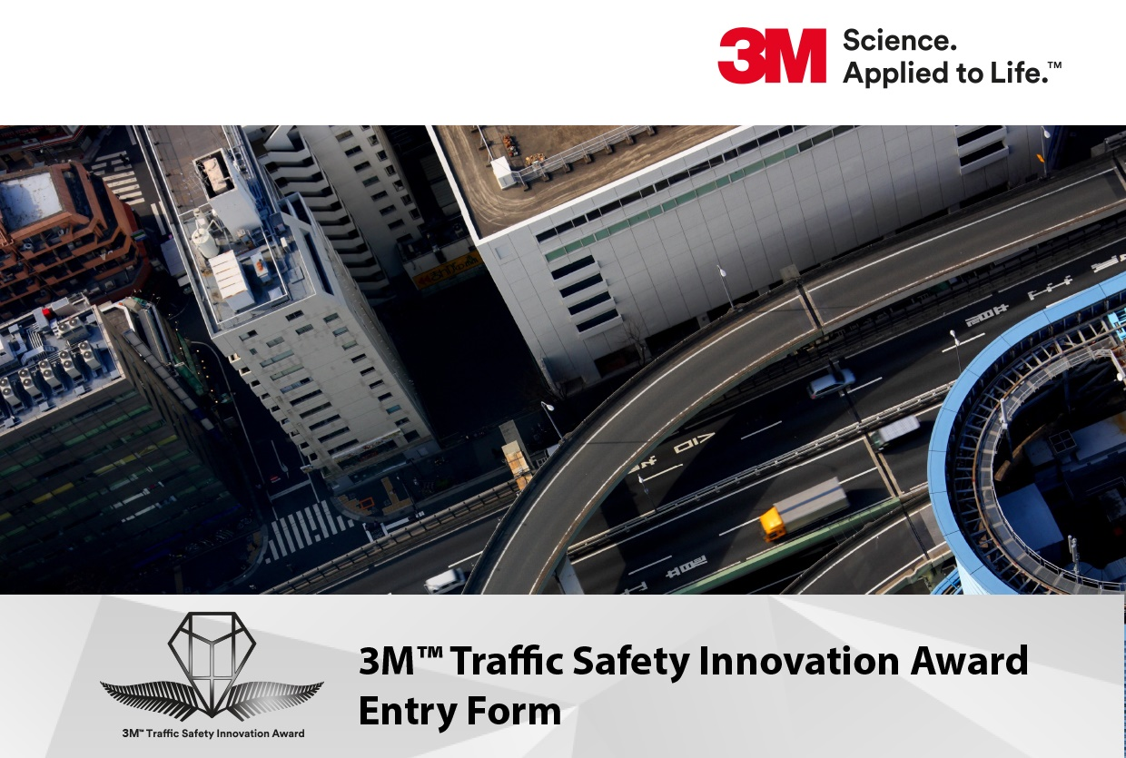
The 3M Traffic Safety Innovation Award is based on the Safe System approach, which aims for a more forgiving road system that takes human fallibility and vulnerability into account. Under a Safe System we design the whole transport system to protect people from death and serious injury.
Under the Safe System approach, all system designers share the responsibility for road safety outcomes. System designers include planners, engineers, parents, policy makers, enforcement officers, educators, utility providers, insurers, vehicle manufacturers and importers, the media, fleet managers and many more.
The award seeks any participants in the system design to put forward proposals that show innovative thinking under one of the four pillars of the Safe System approach: Safe roads and roadsides; Safe speeds; Safe road use; Safe vehicles.
The winner of the award will be announced at the Transportation Group conference in Tauranga in March 2022, at which finalists will present their project. The winner or team leader of the winning project will win a trip to the 2023 ATSSA conference in USA and visit the 3M Head Office (Covid-19 travel restrictions permitting). The winning project will also be promoted by 3M and the Transportation Group through media and industry channels.
Conditions of Entry are contained on Page 2. The application form itself starts on Page 3.
If you have any further questions regarding this award or the application process, please feel free to contact the Transportation Group’s Awards coordinator Daniel Newcombe at: daniel.newcombe@at.govt.nz

Conditions of Entry
- Competition commences on 8th November 2021. Applications must be received by 5 pm 28th January 2022.
- The Promoter is 3M Australia Pty Limited.
- To enter, applicants must complete the official entry form and submit by emailing the entry form in full to daniel.newcombe@at.govt.nz
- To be valid, applications must be on the Award application form and submitted electronically, in Microsoft Word or pdf format. The application may be no more than ten A4 pages in total.
- Supporting images and diagrams may be inserted within the form, but the total file size must not exceed 5 Mb. Other supporting material can be identified within this application under Section C (f). However, applicants should ensure that their applications are able to completely represent the merits of their proposals without the judges needing to reference other materials.
- Judging will be undertaken by a panel selected by the Engineering New Zealand Transportation Group. Each application will be judged on merit and originality. The judges’ decision is final and no correspondence will be entered into.
- Entry is open to New Zealand residents only, and projects on which applications are based must be New Zealand projects. The Promoter’s Employees and their immediate families are not eligible to apply.
- If selected as a finalist, the Team Leader for each application must register and attend the 2022 Transportation Group Conference in Tauranga, to present their application to delegates and be available to participate in the awards ceremony.
- Winners will be announced at the annual Transportation Conference.
- The Promoter reserves the right to verify the validity of entries and reserves the right to disqualify any applicant for submitting an entry not in accordance with these Conditions of Entry or containing material which is factually incorrect.
- Applicants may submit only one application each year.
- The Team Leader of the winning entry will receive a trip to the USA to attend the ATSSA Annual Convention and Traffic Expo in 2023 and visit 3M Global Headquarters in Minnesota (Covid travel restrictions permitting).
- The prize includes a return economy flight from a New Zealand airport to the ATSSA Conference and then to St Paul Minnesota. Any additional charges incurred for any deviation from this itinerary will be borne by the winning entrant.
- Applicants must ensure that their entry for this Award is in accordance with their agency’s or any applicable government policy, and that they will be able to accept the Prize and undertake the travel if their application is chosen as the winner.
- The prize is not transferable or exchangeable and cannot be taken as cash.
- The Promoter shall not be liable for any loss or damage whatsoever which is suffered (including but not limited to indirect or consequential loss) or for personal injury that is sustained in connection with the prize, except for any liability which cannot be excluded by law.
- Applicants consent to the Promoter disclosing their submission to 3M Australia Pty Limited and any part of that application or supporting materials may be used for future promotional purposes of the Award.
3M Award Application Form
[Applications should use no more than ten A4 pages, starting from this page, and must comply with the Conditions of Entry outlined above.
Text in square brackets can be removed from your application to save space, if desired.]
SECTION A: Applicant Details
Name of Applicant:
Position:
Agency Name:
Applicant Phone (daytime):
Applicant Phone (mobile):
Applicant Email Address:
SECTION B: Team Member Details
 | First Name | Family Name
Team Leader
Team Member 2
Team Member 3
Team Member 4
Team Member 5
Team Member 6
Team Member 7

SECTION C: Project Details
- Project Title:

[Describe your (team’s) innovative achievement in planning and implementing a cost-effective road or traffic safety treatment or initiative that stands out beyond traditional activities and has delivered improved safety. Please comment specifically on the following aspects below in your response, as these are the judging criteria:]
- The need for the intervention (20%):
- The innovative thinking involved (30%):
- The effectiveness of the intervention (30%):

- The extent of the benefits to a wide range of transport system users (20%):

- Other supporting documentation (optional):

